SMEET SINGH

OCTOBER BATCH-2024

Tasks Learners have to develop a dashboard to support the answers to the following questions and suggestions for places for newer restaurants.

**Objective Questions:**

1. What is the total no. of tables present in the data?

ANS. There a 2 tables present in the data.

2. What is the total no. of attributes present in the data?

ANS. TOTAL NO OF ATTRIBUTES PRESENT IN THE DATA IS 20

3. How many categorical columns are there in the data? [Search about categorical and continuous data, and try to answer this question.

ANS. THRE ARE 12 CATOGERICAL COLUMNS IN THE DATA WHICH ARE RestaurantName, City, Address, Locality, LocalityVerbose, Cuisines, Currency, Has_Table_booking, Has_Online_delivery, Is_delivering_now, Switch_to_order_menu, DateKey_Opening

1. The data consists of some inconsistent and missing values so ensure that the data used for further analysis is cleaned.

ANS. Using conditional formatting first I searched for any blank cell in the given data and highlighted it,So the missing values are IN THE CUISINS COLUMN THERE IS 9 NULL VALUES,ROW NUMBER OF THE NULL VALUES IS 8654, 8667, 8693, 8701, 8764, 8771, 8794, 8876, and 8903.I have removed the blank column using filter options

I have checked if there is any duplicate by using the "Remove Duplicates" feature under the "Data" tab to find duplicate entries.There is no duplicated in the given data

1. Using the LookUp functions, fill up the countries in the original data using the country code.

ANS. USING LOOKUP FUNCTIONS,I HAVE FILLED UP THE COUNTRIES COLUMN BY USING COUNTRY CODE. THE FORMULA IS-=VLOOKUP(C2,'country description'!A:B,2,0),WHERE C COLUMN IS COUNTRY CODE COLUMN. I have taken range from another sheet named country description.

1. Create a table to represent the number of restaurants opened in each country

ANS.I HAVE CREATED A TABLE USING PIVOT.I HAVE PUT COUNTRY IN ROWS AND PUT RESTAURANT NAME IN VALUES COLUMN TO COUNT NO OF RESTAURANTS IN EACH COUNTRY.

1. Also, the management wants to look at the number of restaurants opened each year, so provide them with something here.

ANS. I HAVE DONE THIS QUESTION BY CREATING PIVOT TABLES ,BUT FIRST I EXTRACT THE OPENING YEAR FROM Datekey_Opening column by using the left funcion like =LEFT(P2,4) WHERE P IS THE Datekey_Opening COLUMN AND 4 IS THE YEAR IN THIS.

1. What is the total number of restaurants in India in the price range of 4

ANS. NUMBER OF RESTAURANTS IN THE PRICE RANGE 4 IS 388 BY USING PIVOT AND FILTERING THEM TO RANGE 4.

9.What is the average number of voters for the restaurants in each country according to the data?

ANS. I HAVE DONE IT USING PIVOT TABLE IN THE EXCEL SHEET BY PUTTING COUNTRIES INTO COLUMN AND VOTES IN VALUE AREA,I HAVE CHANGED ITS FIELD SETTINGS TO AVERAGE.

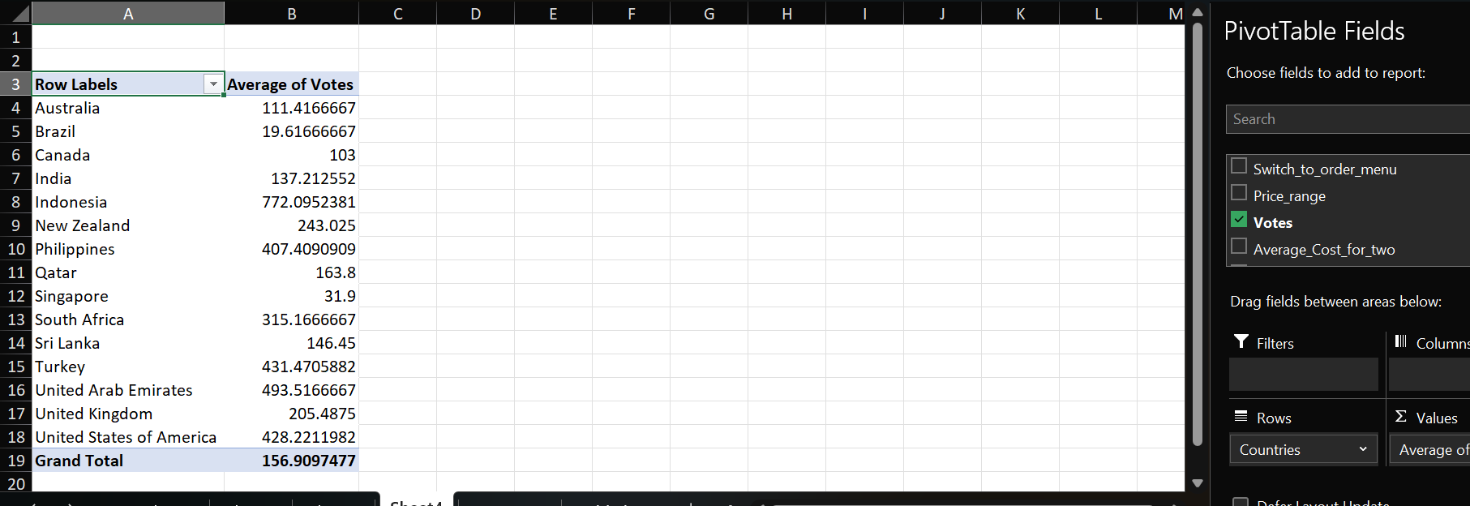

10.Calculate the average rating for all the restaurants that have price_range 4 and provide online delivery. Use only the “IF” function, Logical Operators, and Aggregation functions to solve this problem. [Note: Don’t use Conditional aggregation in this question.]

ANS. I HAVE CALCULATED THE RESTAURANTS HAVING PRICE_RANGE<4 AND PROVIDE ONLINE DELIVERY BY USING IF AND AVERAGE OPERATOR BY USING THE FORMULA =AVERAGE(IF((L2:L9552<4)*(I2:I9552="Yes"),O2:O9552))

where L is Price Range column,I is has online delivery column and O is the rating column

So the answer is 3.273 and it is mention in AG column in excel file in raw data sheet

11.Using Conditional formatting highlight the rows of restaurants that are located in the countries or cities that you’ve suggested to the management for opening new restaurants.

ANS. I have highlighted the rows of countries which I have selected the to opening new restaurants,The restaurants opening countries are-Brazil,south africa and turkey which I have highlighted with different colours. So using conditional formatting using formula =IF($R1’”Country Name”,TRUE,FALSE) ,So I have highlighted entire row containing brazil in green,Turkey in orange and blue for south africa.

12.Create a new customized price column that consists of the abbreviation/symbol of the currency along with the Average_cost_for_two value. [Use string operations to do this task.

ANS.I HAVE CREATED A NEW CUSTOMIZED PRICE COLUMN THAT CONSISTS OF CURRENCY ALONG WITH AVERAGE_COST_OF_TWO VALUE,I HAVE USED CONCATENATE FUNCTIONS TO DO THAT.FIRST I EXTRACTED THE CURRENCY SYMBOL FROM CURRENCY SYMBOL USING =MID(G2, FIND("(", G2) + 1, FIND(")", G2) - FIND("(", G2) - 1) IN COLUMN Y AND FIND OUT THE REQUIRED VALUE OF THIS QUESTION IN AD COLUMN IN RAW DATA USING CONCATENATE FUNCTIONS i.e =Y2 & N2

13.How can you create an array formula in Excel or Google Sheets to count the number of restaurants listed that do not offer online delivery, are in the lowest price range, and have an average cost for two people less than or equal to 250 Indian Rupees?

Answer : To calculate the total number of restaurants that do not offer online delivery, are in the lowest price range, and have an average cost for two people less than or equal to 250 Indian Rupees, I have used countifs function to do that,first I have converted the average cost of two in rupees for all countries in AD Column by using vlookup function =VLOOKUP(G2,'Currency exchange'!$D:$E,2,0)*N2 and then by using countifs function in AI Column =COUNTIFS(I:I,"No",L:L,"1",AF:AF,"<=250") the answer comes is 1691 that is given in excel raw data sheet.

**Subjective Question:**

1. Suggest a few countries where the team can open newer restaurants with lesser competition. Which visualization/technique will you use here to justify the suggestions?

ANS. According to this chart, it is clear that INDIA and USA has most number of Restaurants, so we will exclude these as higher number of restaurants will result in more competition. U can see in this graph

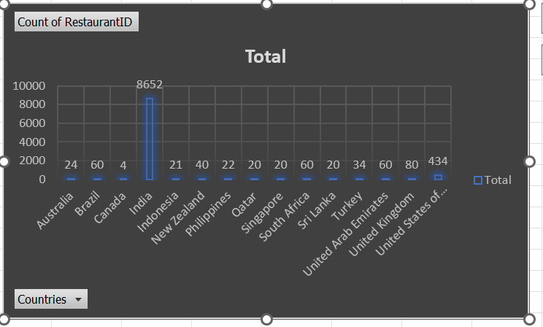

SO I HAVE USED THE BAR CHART VISUALIZATION TECHNIQUE TO JUSTIFY MY SUGGESTION THAT INDDIA AND USA HAVE MOST NO OF RESTAURANT COMPARED TO ALL OTHER COUNTRIES,SO WE WILL EXCLUDE THESE COUNTRIES.

According to below chart, we can see that from Canada to Singapore ,the Expenditure is quite high. So, keeping in mind the expenditure also, we would further filter out the countries.

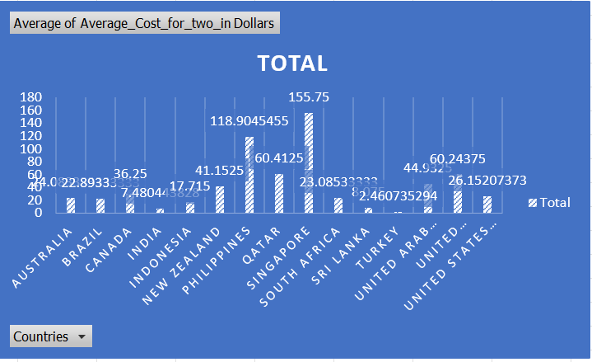

HERE WE CAN SEE FROM THE CHART THAT CANADA,NEWZEALAND,UAE,QATAR,UK,PHILIPINES,SINGAPORE ,THE EXPENDITURE IS QUITE HIGH,SO FROM KEEPING IN MIND THIS,WE WILL ALSO FILTER OUT THESE COUNTRIES.

ALSO South Africa, Brazil and Turkey have the most ratings in Excellent and Very Good Category. This means that people prefer eating in these countries and give better ratings to food

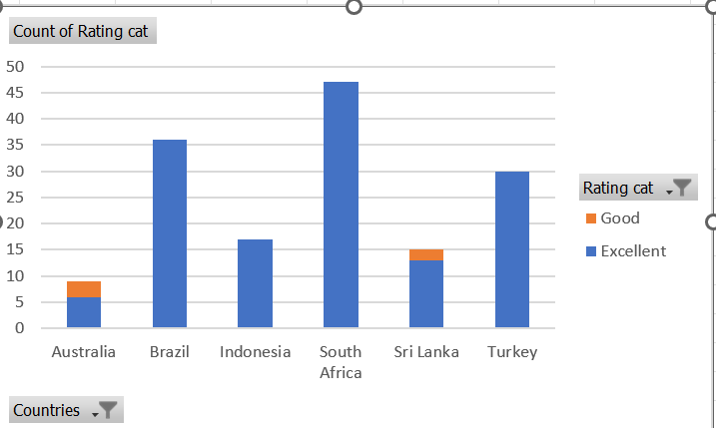

SO FROM MY POINT OF VIEW TURKEY,BRAZIL,SOUTHAFRICA ARE THE COUNTRIES WHERE WE CAN OPEN NEW RESTAURANTS WITH LESSER COMPETITION .

1. Come up with the names of States and cities in the suggested countries suitable for opening restaurants.

ANS.Cities with Highest Count of Restaurants : Sao Paulo , Rio de Janeiro , Brasilia ,Cape Town, Pretoria , Ankara

WE CAN FIND IT FROM THE BELOW CHART

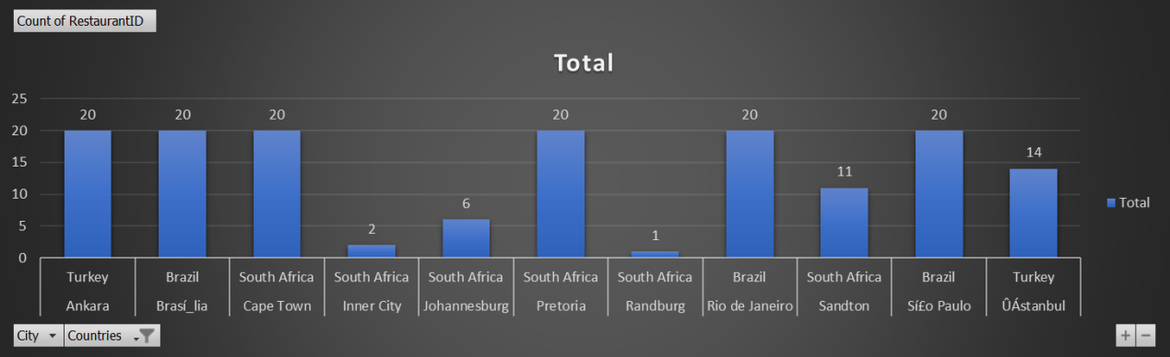

NOW LOOKING AT EXCELLENT RATINGS IN CITY -RIO-DE JANERIO,ANKARA AND PRETORIA RATINGS STANDS HIGH,SO THESE ARE THE CITIES IN WHICH WE CAN OPEN NEW RESTAURANTS.

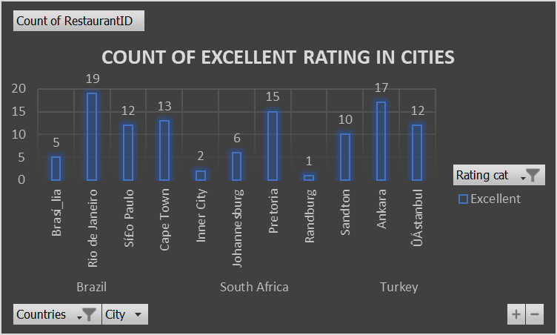

1. According to the countries you suggested, what is the current quality regarding ratings for restaurants that are open there?

ANS. I'll start by exploring the Rating column of the raw data, and then I'll find the average rating for each country. This will give us a good understanding of the current restaurant quality in those countries.SO THE CONTRIES I SUGGESTED WAS BRAZIL,SOUTH AFRICA AND TURKEY WHICH HAS AVERAGING RATINGS OF 3.8466,4.21 AND 4.3 WHICH IS PRETTY GOOD IN RESPECTIVE TO OTHER COUNTRIES.

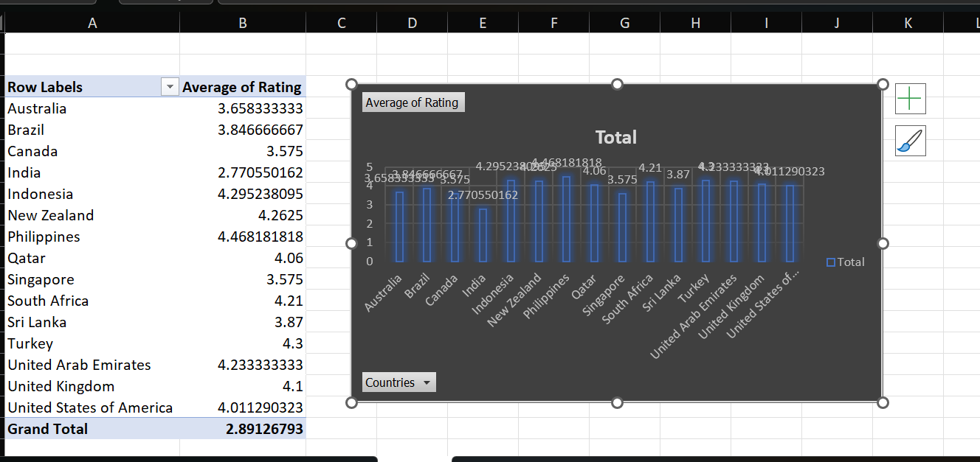

RECOMMENDETIONS-

1. Focus on High-Rated Restaurants: Encourage users to visit restaurants with high average ratings and a significant number of reviews. This can enhance their dining experience.

2. Highlight Popular Cuisines: If certain cuisines are consistently rated higher, consider promoting these cuisines in marketing campaigns or special events.

3. Encourage Customer Feedback: Encourage restaurants to solicit more reviews from customers to improve their visibility and credibility. This can help new customers make informed decisions.

4. Monitor Competitors: Keep an eye on competitors in the same region or cuisine type. Understanding their ratings and customer feedback can provide insights into market trends and customer preferences.

6. Promote New Entrants: If new restaurants are opening with high ratings, consider featuring them prominently on the platform to attract customers looking for new dining experiences.

7. Address Low Ratings: For restaurants with low ratings, consider providing them with insights from customer reviews to help them improve their offerings and service.

4.Also, what is the current expenditure on food in the suggested countries, so we can keep our financial expenditure in control?

ANS. FOR DOING THIS,FIRST I HAVE CONVERTED ALL CURRENCY VALUES IN DOLLARS LIKE THIS-

|  |  |
| --- | --- |
| Currency | Value in Dollars |
| Indian Rupees(Rs.) | 0.012 |
| Dollar($) | 1 |
| Pounds(Œ£) | 1.26 |
| NewZealand($) | 0.59 |
| Emirati Diram(AED) | 0.27 |
| Brazilian Real(R$) | 0.17 |
| Turkish Lira(TL) | 0.029 |
| Qatari Rial(QR) | 0.27 |
| Rand(R) | 0.055 |
| Botswana Pula(P) | 0.074 |
| Sri Lankan Rupee(LKR) | 0.0034 |
| Indonesian Rupiah(IDR) | 0.000063 |

Now I find the average of average cost of two in dollars to find out the exact expentidure.

THE SUGGESTED COUNTRIES WERE BRAZIL,SOUTH AFRIKA AND TURKEY WHICH HAVE THEIR EXPENDITURE 22.8933,23.085 AND 2.4607 RESPECTIVELY.

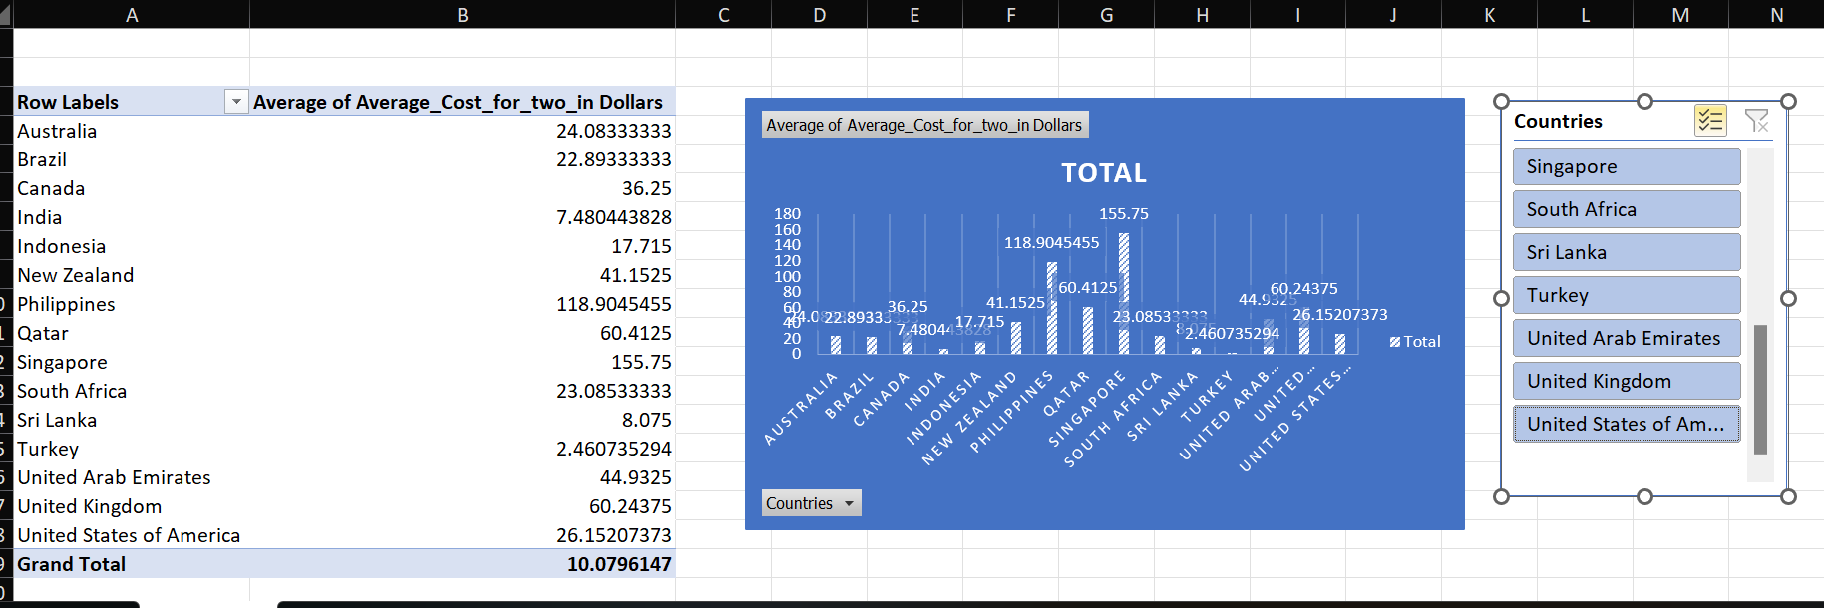

RECOMMENDATIONS-

* + Provide insights on cost-effective dining options based on the analysis.
  + Suggest popular restaurants that offer good value for money in each country.

5.Come up with the names of restaurants from the recommended states that are our biggest competitors and also those that are rated in the lower brackets, i.e. 1-2 or 2-3.

ANS. I HAVE DECIDED 3 COUNTRIES-BRAZIL,SOUTH AFRICA AND TURKEY.

THE STATE THAT ARE BIGGER COMPETITORS ARE WHICH HAVE RATING CATEGORY EXCELLENT(4-5)

THE RESTURANT NAME IS BRAZIL HAVE BIGGEST COMPETITOR WITH EXCELLENT RATINGS ARE AS FOLLOWS-

|  |
| --- |
| A Figueira Rubaiyat |
| Aconchego Carioca |
| Amir |
| Aprazí_vel |
| Balada Mix |
| Bibi |
| Braseiro da Gíçvea |
| Cantina Famiglia Mancini |
| Cervantes |
| Coco Bambu |
| Confeitaria Colombo |
| D.O.C Ristorante |
| Esquina Mocotí_ |
| Filí© de Ouro |
| Garota de Ipanema |
| Jiquitaia |
| Leme Light |
| Les 3 Brasseurs |
| Meats |
| Outback Steakhouse |
| Paribar |
| Pesqueiro Eco Gourmet |
| Sainte Marie Gastronomia |
| Shirley |
| Skye - Hotel Unique |
| Sushi Leblon |
| Taco Pep |
| Talho Capixaba |
| Templo da Carne - Marcos Bassi |
| Terraí_o Itíçlia |
| TT Burger |
| Veloso |
| Villa Tevere |
| Zazíç BistríÇ Tropical |
| Grand Total |
|  |

THE RESTURANT NAME IS BRAZIL HAVING LOWER RATINGS BRACKETS I.e (1-2) AND (2-3) ARE -

|  |
| --- |
| Beirute |
| Brazilian American Burgers |
| Buena Carne |
| Cafí© Daniel Briand |
| Cantinho da Gula |
| Casa do Biscoito Mineiro |
| Chez Michou |
| Divino Fogí£o |
| Gero |
| Gopala Hari |
| Kawa Sushi |
| Kinoshita |
| Manzuíç |
| Maori |
| New Koto |
| Paris 6 Classique |
| Pizza íæ Bessa |
| Quiosque Chopp Brahma |
| Red Steak & Burger |
| Rovereto |
| Sandubas Cafí© |
| Super Grill |
| Sushi Loko |
| Taypíç |
| Grand Total |
|  |

THE RESTURANT NAME IS SOUTH AFRICA HAVE BIGGEST COMPETITOR WITH EXCELLENT RATINGS ARE AS FOLLOWS-

|  |
| --- |
| Baobab Cafe & Grill |
| Cafe Del Sol Botanico |
| Capital Craft Beer Academy |
| Carbon Bistro |
| Coco Safar |
| Craft |
| Crawdaddy's |
| Cube - Tasting Kitchen |
| Culture Club - Bar De Tapas |
| El Pistolero |
| Escondido Tapas |
| Geet Indian Restaurant |
| Gemelli Cucina Bar |
| Gibson's Gourmet Burgers & Ribs |
| Harissa Bistro |
| Hogshead |
| Hudsons |
| Jamie's Italian |
| Jarryds |
| Jason Bakery |
| Jerry's Burger Bar |
| Kloof Street House |
| Kream |
| Licorish Bistro |
| Life Grand Cafe |
| Marble |
| Momo Baohaus |
| My Sugar |
| Nobu - One&Only |
| Origin Coffee Roasting |
| Perron |
| Restaurant Mosaic @ The Orient |
| Salsa Mexican Grill |
| Social on Main |
| Spice - The Indian Kitchen |
| tashas |
| The Belgian Triple |
| The Big Mouth |
| The Black Bamboo |
| The Creamery |
| The National |
| The Smokehouse and Grill |
| The Whippet |
| The Wolfpack |
| Truth Coffee |
| Urbanologi |
| Willoughby & Co. |
| Grand Total |

THE RESTURANT NAME IS SOUTH AFRICA HAVING LOWER RATINGS BRACKETS I.e (1-2) AND (2-3) ARE -

|  |
| --- |
| 23 On Hazelwood |
| Active Sushi |
| Baobab Cafe & Grill |
| Beluga |
| Blos Cafe |
| Brooklyn Brothers |
| Cafe Del Sol Botanico |
| Capital Craft Beer Academy |
| Carbon Bistro |
| Coco Safar |
| Craft |
| Crawdaddy's |
| Cube - Tasting Kitchen |
| Culture Club - Bar De Tapas |
| El Pistolero |
| Escondido Tapas |
| Geet Indian Restaurant |
| Gemelli Cucina Bar |
| Gibson's Gourmet Burgers & Ribs |
| Grand Cafí© & Beach |
| Harissa Bistro |
| Hogshead |
| Hudsons |
| Jamie's Italian |
| Jarryds |
| Jason Bakery |
| Jerry's Burger Bar |
| Kloof Street House |
| Kream |
| La Parada |
| Licorish Bistro |
| Life Grand Cafe |
| Marble |
| Momo Baohaus |
| My Sugar |
| Nobu - One&Only |
| Old Town Italy |
| Origin Coffee Roasting |
| Parrot's |
| Perron |
| Remo's Maximilliano |
| Restaurant Mosaic @ The Orient |
| Rocomamas |
| Salsa Mexican Grill |
| Salushi |
| Social on Main |
| Spice - The Indian Kitchen |
| tashas |
| The Belgian Triple |
| The Big Mouth |
| The Black Bamboo |
| The Butcher's Wife |
| The Creamery |
| The National |
| The Smokehouse and Grill |
| The Whippet |
| The Wolfpack |
| Truth Coffee |
| Urbanologi |
| Willoughby & Co. |
| Grand Total |
|  |

THE RESTURANT NAME IN TURKEY HAVE BIGGEST COMPETITOR WITH EXCELLENT RATINGS ARE AS FOLLOWS-

|  |
| --- |
| Aôôk Kahve |
| Baltazar |
| Cafemiz |
| Ceviz AÛôacÛ± |
| Dem Karakí_y |
| Dí_veroÛôlu |
| Draft Gastro Pub |
| Emirgan Sí_tiô |
| Gaga Manjero |
| Hattena Hatay SofrasÛ± |
| íˆukuraÛôa SofrasÛ± |
| J'adore Chocolatier |
| Karakí_y Gí_llí_oÛôlu |
| Kebap 49 |
| MasabaôÛ± |
| MasabaôÛ± Kebapí_Û±sÛ± |
| Meôhur í_zí_elik Aspava |
| Meôhur TavacÛ± Recep Usta |
| NamlÛ± Gurme |
| Nusr-Et |
| Pizza ÛÁl Forno |
| Starbucks |
| Timboo Cafe |
| Turta Home Cafe |
| Valonia |
| Walter's Coffee Roastery |
| YÛ±ldÛ±z Aspava |
| Zigana Pide |
| Grand Total |

THE RESTURANT NAME IS TURKEY HAVING LOWER RATINGS BRACKETS I.e (1-2) AND (2-3) ARE -

|  |
| --- |
| Aôôk Kahve |
| Baltazar |
| Cafemiz |
| Ceviz AÛôacÛ± |
| Dem Karakí_y |
| Dí_veroÛôlu |
| Draft Gastro Pub |
| Emirgan Sí_tiô |
| Gaga Manjero |
| Hattena Hatay SofrasÛ± |
| Huqqa |
| íˆukuraÛôa SofrasÛ± |
| J'adore Chocolatier |
| Karakí_y Gí_llí_oÛôlu |
| Kebap 49 |
| Leman Kí_ltí_r |
| Liva |
| MasabaôÛ± |
| MasabaôÛ± Kebapí_Û±sÛ± |
| Meôhur í_zí_elik Aspava |
| Meôhur TavacÛ± Recep Usta |
| NamlÛ± Gurme |
| Nusr-Et |
| Pizza ÛÁl Forno |
| Starbucks |
| The Bigos |
| Timboo Cafe |
| Turta Home Cafe |
| Valonia |
| Walter's Coffee Roastery |
| YÛ±ldÛ±z Aspava |
| Zigana Pide |
| Grand Total |

I HAVE FOUND THESE USING PIVOT TABLE HINGRATING BUCKETIN COLUMN,RESTAURANT NAME IN ROWS AND COUNT OF RATING BUCKET IN COLUMN.AND AFTER PUTTING SLICER THE PIVOT TABLE LOOKS S FOLLOWS-

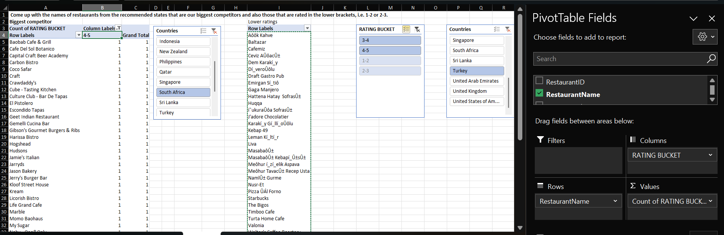

RECOMENDATIONS-

* + Compile a list of the identified restaurants with low ratings and categorize them by cuisine type or location.
  + Use this information to strategize on how to position your restaurant against these competitors.

By following these steps, you can effectively identify and analyze the competitors with lower ratings in your Zomato data analysis project.

6.Which cuisines should we focus on in the newer restaurants to get better feedback? Does the choice of cuisines affect the restaurant ratings?

ANS. THE cuisines should we focus on in the newer restaurants to get better feedback IS

NORTH INDIAN-This cuisine is popular in many regions, particularly in India, and tends to receive favorable ratings due to its rich flavors and variety. 2. Italian Cuisine: Italian food remains a favorite among consumers, with dishes like pasta and pizza consistently receiving high ratings. The familiarity and comfort associated with Italian cuisine can lead to positive customer experiences.

Mexican Cuisine: With its vibrant flavors and diverse offerings, Mexican food has gained a strong following. Tacos, burritos, and enchiladas are particularly well-received, making this cuisine a good choice for new restaurants.

CAFE CUISINE AND ITIALIAN CUISINE ARE THE CUISINE WE SHOULD FOCUS ON OPENING NEW RESTAURANTS.

YES ,THE CHOICE OF CUISINES CAN AFFECT THE RATING BECAUSE OF FOLLOWING REASONS-

Consumer Preferences: The choice of cuisine significantly affects restaurant ratings, as customers often rate their experiences based on their expectations and familiarity with the cuisine.

Quality and Authenticity: Restaurants that maintain high standards of quality and authenticity in their chosen cuisine tend to receive better ratings. Customers appreciate genuine flavors and traditional cooking methods.

Trends and Novelty: Cuisines that align with current food trends, such as veganism or sustainability, can positively impact ratings. Diners are increasingly looking for restaurants that reflect their values and preferences.

Cultural Relevance: Cuisines that resonate with local culture or have a strong community presence often receive better feedback. Engaging with local tastes and preferences can enhance customer satisfaction.

.

RECOMMENDATIONS-

* Menu Development:
  + Curate a menu that highlights the chosen cuisines, ensuring quality and authenticity.
* Marketing Strategy:
  + Promote the unique aspects of the selected cuisines through social media and local advertising to attract customers.
* Feedback Mechanism:
  + Implement a system for gathering customer feedback to continuously improve offerings based on preferences and ratings.

By focusing on these cuisines and analyzing their impact on ratings, new restaurants can position themselves for better feedback and success in the competitive dining landscape.

I am telling these based on the given data and graph-

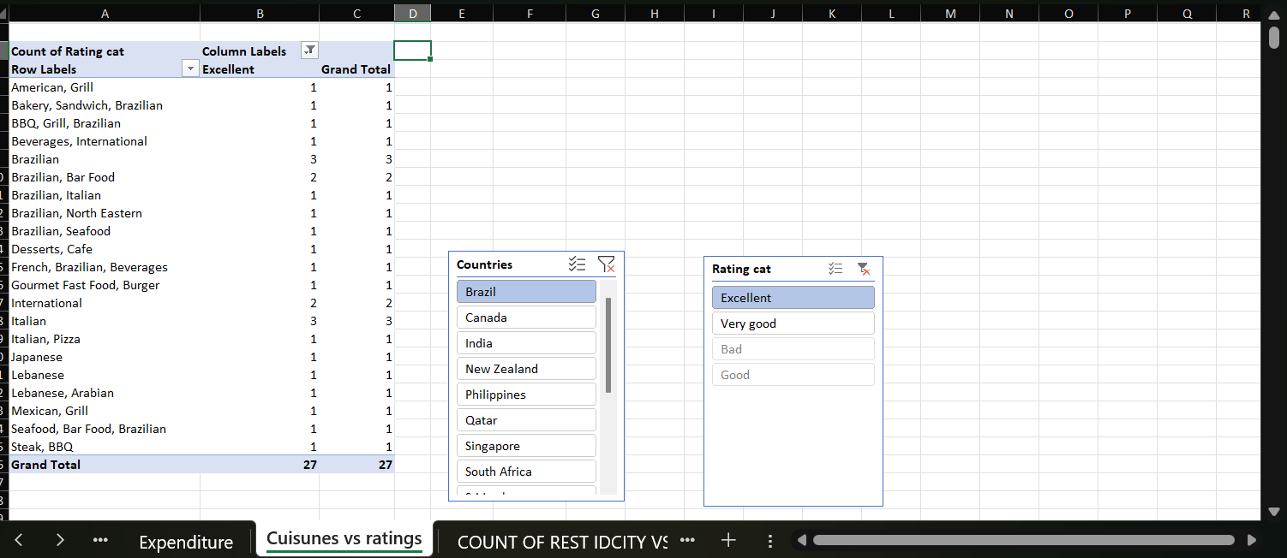

7.According to our current data, should we go for online delivery and table booking? Does that affect the customer’s ratings?

ANS. YES,ACCORDING TO OUR CURRENT DATA,WE SHOULD GO FOR ONLINE DELIVERY AND TSBLE BOOKING,IT WONT MUCH AFFECT THE CUSTOMER’RATING ACCORDING TO GIVEN TABLE AND CHART INSERTED BELOW,BUT FOM MY OPINION IN SOME COUNTRIES LIKE PHILIPINES IT AFFET THE THE CUSTOMER RATINGS,ONLINE DELIVERY HAS VERY MUCH GOOD AND EXCELLENT RATINGS VS HAS TABLE BOOKING.I AM INSERTING THE DATA PIC BELOW-

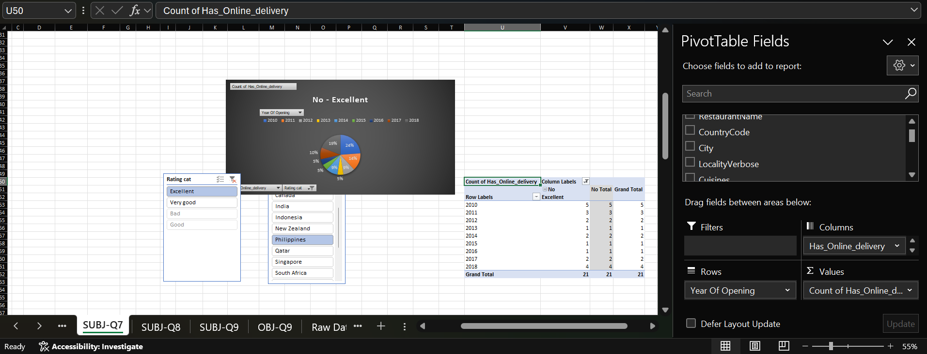

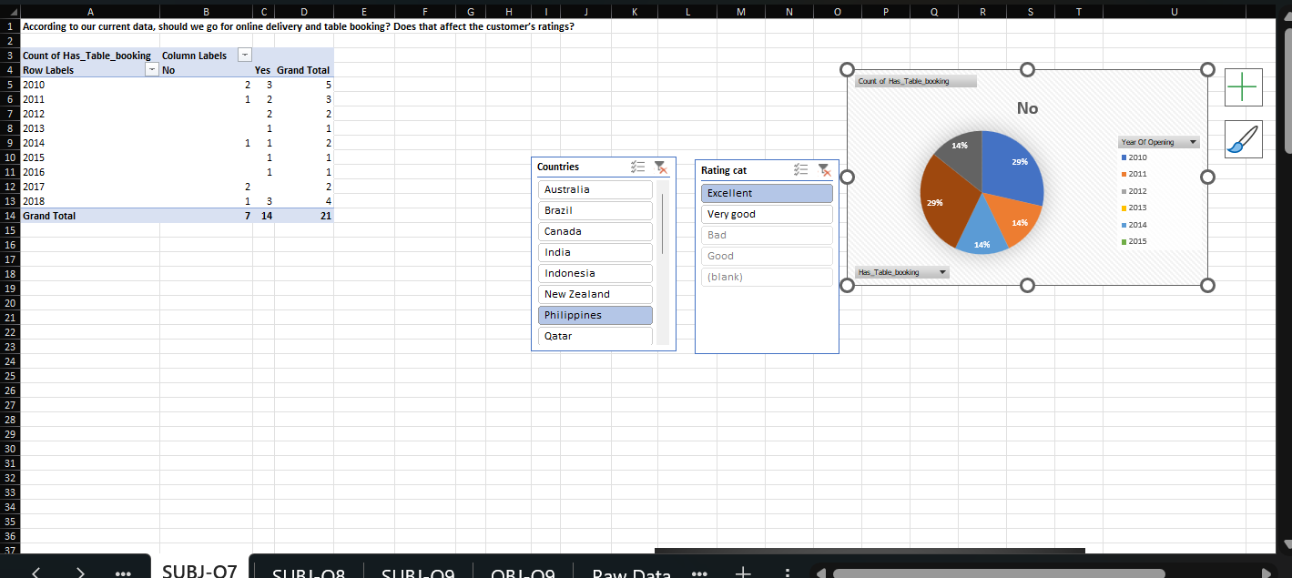

Here we can clearly see that in countries like philippines and other countries also have the great customer ratings when online delivery is introduced ….as the year increases the online delivery becomes more popular and is in demand,so yes,online delivery affects the customer ratings in some ways as the costumers would not have to go to restaurant to taste the restaurant menu.I have inserted the pivot table and pie chart as mentioned in the feedback ,it is clearly seen in online delivery th ratings of the restaurant has been increased,I also have out slicers of country and ratings so that the managing team or user can check it for different countries also and analyze the data.

8.Should the team keep the rate of cuisines higher? Will that affect the feedback? According to our data are the rates of cuisines and ratings, correlated?

(BAD CATEGORY IN PRICE RANGE 1)

(EXCELLENT CATEGORY IN PRICE RANGE 1)

Here we can clearly see that in price range 1 of bad category count is greater than excellent category in price range 1.

Also I have find the relation between average cost of 2 and ratings using correl function CORREL(O2:O9552,X2:X9552),THE VALUE I got is 0.309,so correlation coefficient of 0.309 indicates a weak to moderate positive correlation between the average cost for 2 and customer ratings in Zomato data.

Our analysis reveals a weak to moderate positive correlation (0.309) between average cost for 2 and customer ratings. This suggests that restaurants could potentially increase their prices modestly, provided they offer a corresponding increase in value to justify the higher cost. However, they should not solely rely on price increases to improve ratings, as other factors are also crucial."

Coming to second part of question-

We found a weak to moderate positive correlation (0.309) between average cost for 2 and customer ratings, indicating that price does have some influence on customer feedback. However, the relationship is not very strong, suggesting that other factors also play a significant role in shaping customer perceptions.  
I have also made a chaart of average rating vs average cost of two in INR

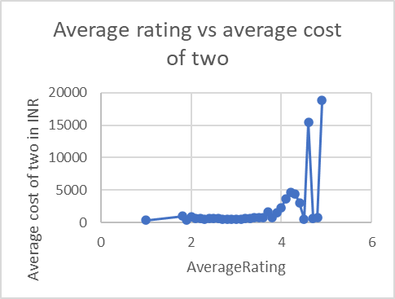

9.) What is the distribution of the number of restaurants of different price ranges in all the countries?

ANS. THIS I HAVE DONE USING PIVOT TABLE BY PUTTING PRICE RANGE IN COLUMN,COUNTRIES IN ROWS AND IN VALUES COUNT O RESTAURANT NAME AND I HAVE PUT SLICERS FOR COUNTRIES ,HERE WE CAN SEE the distribution of the number of restaurants of different price ranges in all the countries BY

Analyze the Results:

Look for patterns in the distribution of restaurants across price ranges in different countries.

Identify which price ranges are most popular in specific countries and any notable trends.

Draw Conclusions:

* + Use the insights gained from the analysis to inform decisions or recommendations regarding restaurant pricing strategies in different markets.

THE SCREENSHOT OF EXCEL FILE IS BELOW ATTACHED

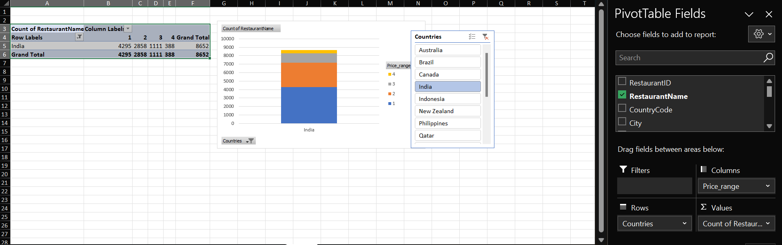

BY USING SLICERS WE CAN SEE PATTERNS FOR DIFFERENT COUNTRIES.

10.) Explain your approach in brief for suggesting countries/cities in order to open new restaurants, if the objective and subjective questions would have not been given to assist you. [you have to give bullet pointers in order to answer this question]

We should use following approach for suggesting countries/cities in order to open new restaurants if the subjective and objective questions would not have given

1. Define our Target Market

* Identify Ideal Customer Profile: Determine the demographics, preferences, and behaviors of our target customer. Who are we trying to attract? (e.g.,, income level, cuisine preferences)
* Existing Zomato User Data: Analyze existing Zomato user data to understand current customer segments and their preferences.

2. Analyze Current Market Conditions

* Competitive Landscape: Research the existing restaurant scene in potential countries/cities.
  + Are there gaps in the market?
  + Which cuisines are underrepresented?
  + What are the prevailing price points?
* Economic Factors: Consider economic indicators like population growth, disposable income.
* Cultural Factors: Assess cultural factors that may influence dining habits, such as local cuisine preferences and dining-out frequency.

3. Leverage Zomato's Data

* Restaurant Performance Data: Analyze historical data on restaurant performance on the Zomato platform.
  + Which cuisines or restaurant types have the highest ratings and order volumes?
  + Are there regional variations in performance?
* User Reviews and Ratings: Examine user reviews and ratings to understand customer satisfaction and identify areas for improvement.
* Search Trends: Analyze search trends on Zomato to understand what users are looking for in different locations.

4. Prioritize Potential Locations

* Develop a Scoring System: Create a scoring system based on the factors identified above. Assign weights to different factors based on their importance.
* Rank Countries/Cities: Use the scoring system to rank potential countries/cities based on their overall suitability.
* Consider Market Entry Strategies: Research different market entry strategies (e.g., franchising, joint ventures) for each location.

5. Present Recommendations

* Data Visualization: Use maps, charts, and graphs to visually present your findings.
* Actionable Insights: Provide specific recommendations on which countries/cities to prioritize and potential market entry strategies.